Lab 1: Requirements Engineering & UML Use-Case Modelling
Scenario #63 – Community Solar Credit Allocation Manager
DELIVERABLE 1
Functional Requirements (FR-001 to FR-005)
Req ID | Type | Description | Priority | Acceptance Criteria | Rationale
FR-001 | Functional | The system shall record solar generation units (kWh) received from smart meter feeds for each prosumer resident. | High | Pass: Valid solar generation data is stored with the corresponding resident and time period.  Fail: Invalid or incomplete meter data is rejected. | Accurate generation records are required to calculate available solar credits.
FR-002 | Functional | The system shall calculate and display the available solar credit balance for each prosumer resident. | High | Pass: The displayed credit balance reflects the resident's recorded generation and previous credit transfers.  Fail: The balance does not match the stored transaction records. | Residents need to know how many credits they can use or transfer.
FR-003 | Functional | The system shall allow prosumer residents to transfer surplus solar credits to another resident's account. | High | Pass: Transferred credits are deducted from the sender and added to the recipient.  Fail: A transfer exceeding the sender's available balance is rejected. | Provides the required peer-to-peer solar credit sharing.
FR-004 | Functional | The system shall apply eligible solar credits to a resident's monthly utility billing offset. | High | Pass: Eligible credits are deducted from the resident's credit balance and reflected in the monthly billing statement.  Fail: Ineligible or insufficient credits are not applied. | The main purpose of the credits is to reduce monthly utility billing.
FR-005 | Functional | The system shall allow the co-op manager to view solar generation, credit transfers, and monthly billing offset records. | Medium | Pass: The co-op manager can view accurate records for selected residents and billing periods.  Fail: Unauthorized users cannot access manager records. | Helps the co-op manager monitor and manage community solar activity.

Non-Functional Requirements (NFR-001 & NFR-002)
Req ID | Type | Description | Priority | Acceptance Criteria | Rationale
NFR-001 | Nonfunctional – Performance & Reliability | The system shall process and store hourly solar generation data for 500 households while maintaining 99.9% availability. | High | Pass: Testing confirms data from 500 households is processed correctly and the system meets the 99.9% availability target.  Fail: The system fails to process the required load or falls below the availability target. | Ensures the system can reliably support a community-scale solar network.
NFR-002 | Nonfunctional – Security | The system shall ensure that solar credit and billing information can only be accessed or modified by authorized users. | High | Pass: Unauthorized access attempts are denied and only authenticated users can view or modify permitted records.  Fail: An unauthorized user can access or modify protected information. | Protects solar credit and billing information from unauthorized access or modification.

DELIVERABLE 2
ACTORS
- Prosumer Resident
- Co-op Manager
- Smart Meter
USE CASES
- UC-01: Record Solar Generation
- UC-02: View Solar Credit Balance
- UC-03: Transfer Solar Credits
- UC-04: Apply Credits to Utility Bill
- UC-05: View Solar & Billing Records

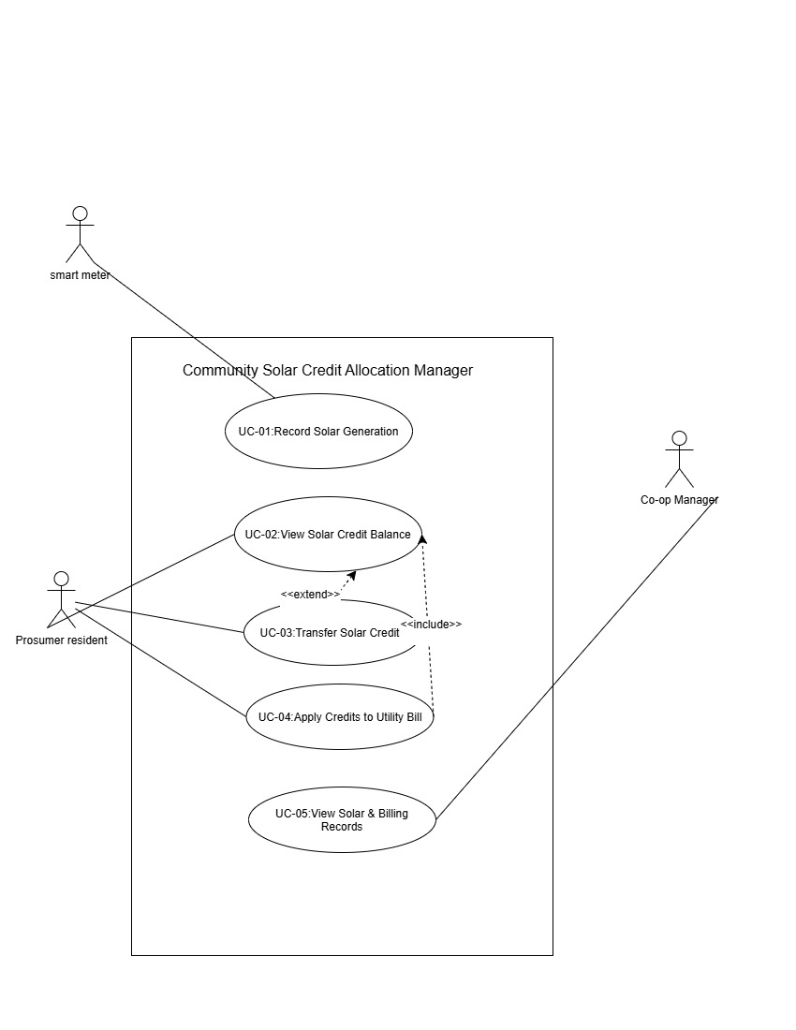

DELIVERABLE 3

Use-Case Flow Specification – UC-03: Transfer Solar Credits
Use Case Name
UC-03: Transfer Solar Credits
Primary Actor
Prosumer Resident
Preconditions
- The prosumer resident is registered and authorized to use the system.
- The prosumer resident has a valid solar credit balance.
- The recipient is a valid resident account in the community solar system.
Postconditions
- The transferred credits are deducted from the sender's credit balance.
- The transferred credits are added to the recipient's credit balance.
- The credit transfer transaction is recorded in the system.
Main Success Scenario
- The Prosumer Resident selects "Transfer Solar Credits".
- The system displays the resident's available solar credit balance.
- The Prosumer Resident enters or selects the recipient's account.
- The Prosumer Resident enters the number of solar credits to transfer.
- The system validates the recipient account and transfer amount.
- The system checks that the requested credits do not exceed the sender's available balance.
- The Prosumer Resident confirms the transfer.
- The system deducts the transferred credits from the sender's account.
- The system adds the transferred credits to the recipient's account.
- The system records the credit transfer transaction.
- The system displays a transfer-success confirmation.
- The use case ends successfully.
Alternate Flow
6a. Insufficient Credit Balance
- The system detects that the requested transfer amount is greater than the sender's available credit balance.
- The system rejects the transfer.
- The system displays an "Insufficient Solar Credit Balance" message.
- The Prosumer Resident is asked to enter a smaller transfer amount or cancel the transaction.
- If the resident enters a valid amount, the system continues from Step 6 of the Main Success Scenario.
- If the resident cancels, the transfer is terminated and no credits are changed.

